ConsoleTools
Tutorials

Introduction

ConsoleTools
The ConsoleTools are a set of user controls that can be used in a console application to easier read/write data from the user.

Tutorial Description
In this tutorial, we’ll build a stateful console application. This means that, once it is started, the application will run until the user explicitly exits it.
In this way we are able to keep the list of people in memory for the duration of the application. We will then expose commands to add and display the people. Something like an address book:
- add a new person;
- display the list of persons;
- display details about one person;
The action to be performed will be selected from a menu.
Note: We’ll not implement other functionalities, like delete and edit, because they do not add value to the tutorial, but they can be easily added after the add and display functionalities are implemented.

Tutorial 1 – Menu (ScrollableMenu)

Controls
- ScrollableMenu – The menu control
- LabelMenuItem – Items in the menu
- ICommand – Commands associated with the menu items, that are executed when the user selects an the item.

Description
The difference between a stateless and a stateful application is that, the later will keep running once it is started. Therefore it needs a mechanism through which the user will specify what actions to be executed. For this tutorial we choose a menu. The user will select an item using the up/down and enter keys.

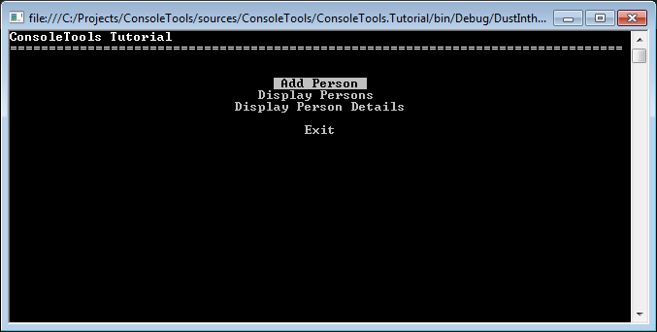
Note: For the same purpose as ScrollableMenu, the ConsoleTools library contains also the TextMenu and Prompter controls.

Implementation

Step 1) Create AddressBookApplication class
First, we create a class named AddressBookApplication that has a Run() and a RequestExit() methods:
internal class AddressBookApplication
{
public void Run()
{
...
}

public void RequestExit()
{
...
}
}
Note: We’ll explain later why the RequestExit() method is called that way and not simply Exit().
This is how we call the AddressBookApplication class from our Main() method:
private static void Main(string[] args)
{
...

AddressBookApplication application = new AddressBookApplication();
application.Run();

...
}

Step 2) Create the menu
Now, lets create the menu containing the menu items for each action we described earlier:
- Add Person – Lets the user create a new person
- Display Persons – Displays a table with all the persons (just the name)
- Display Person Details – Displays details about one person
internal class AddressBookApplication
{
readonly AddressBook addressBook = new AddressBook();

public void Run()
{
List<IMenuItem> menuItems = new List<IMenuItem>
{
new LabelMenuItem
{
Text = "Add Person",
Command = new AddPersonCommand(addressBook)
},
new LabelMenuItem
{
Text = "Display Persons",
Command = new DisplayPersonsCommand(addressBook)
},
new LabelMenuItem
{
Text = "Display Person Details",
Command = new DisplayPersonDetailsCommand(addressBook)
},
new LabelMenuItem
{
Text="Exit",
Command = new ExitCommand(this)
}
};

ScrollableMenu menu = new ScrollableMenu(menuItems);
}

public void RequestExit()
{
...
}
}
Each menu item has an associated command that will be automatically executed when the user selects the menu item.
Also we created an AddressBook instance that contains the persons. It is passed to all the commands we created.

Step 3) Display the menu
The menu must be displayed repetitively, in a loop, because the Display method returns after each time the user selects an item:
internal class AddressBookApplication
{
readonly AddressBook addressBook = new AddressBook();

public void Run()
{
List<IMenuItem> menuItems = new List<IMenuItem>
{
...
};

ScrollableMenu menu = new ScrollableMenu(menuItems);

while (true)
{
menu.Display();
}
}

public void RequestExit()
{
...
}
}

Step 4) Exit the loop (and the application)
We still want to end the loop and exit the application when the user requests it. For that, we create a flag isCloseRequested that we use as a condition for exiting the while loop.
The flag is initially false and will be set by the RequestExit() method, thus triggering the exit.
Note: The RequestExit() method is not called simply Exit() because it does not actually exit the application. It just sets the flag based on which the loop must close itself.
To allow the user to exit the application, we create the “Exit” menu item that will call the RequestExit() method.
internal class AddressBookApplication
{
private bool isCloseRequested;
readonly AddressBook addressBook = new AddressBook();

public void Run()
{
List<IMenuItem> menuItems = new List<IMenuItem>
{
...

new SeparatorMenuItem(),
new LabelMenuItem
{
Text="Exit",
Command = new ExitCommand(this)
}
};

ScrollableMenu menu = new ScrollableMenu(menuItems);

while (!isCloseRequested)
{
menu.Display();
}
}

public void RequestExit()
{
isCloseRequested = true;
}
}
The “Exit” menu item is associated with the ExitCommand that is calling the AddressBookApplication.RequestExit() method:
internal class ExitCommand : ICommand
{
private readonly AddressBookApplication addressBookApplication;

public bool IsActive { get; } = true;

public ExitCommand(AddressBookApplication addressBookApplication)
{
if (addressBookApplication == null)
throw new ArgumentNullException(nameof(addressBookApplication));

this.addressBookApplication = addressBookApplication;
}

public void Execute()
{
addressBookApplication.RequestExit();
}
}

Tutorial 1 – Read values from Console

Controls
- ValueRead (StringRead, FloatRead)
- ListRead

Description
Lets implement the “Add person” functionality.
A Person has the following information:
- First Name: string
- Last Name: string
- Birthday: DateTime
- Phone Number: string
- Email Address: string
- Height: float
- Preferred Beverages: List<string>

